RUBIK’S CUBE HOBBY GROUP
TAKNEEK PROBLEM STATEMENT:

Event 1: 3x3x3 speed-solve Freshers only (25 points)
This is the regular 3x3x3 speed-solve in which a participant will come and will try to solve the cube in minimum time possible. If the timer reaches 5 min, the solve will be considered as DNF (Did not Finish). All the rules and regulations will be as prescribed by World Cubing Association. (http://worldcubeassociation.org/regulations/)
This will be an individual event in which there is no limit on participation from any pool.
Event 2: 2x2x2 speed-solve Freshers only (15 points)
This is the regular 2x2x2 speed-solve in which a participant will come and will try to solve the cube in minimum time possible. If the timer reaches 2 min, the solve will be considered as DNF (Did not Finish) All the rules and regulations will be as prescribed by World Cubing Association. (http://worldcubeassociation.org/regulations/)
This will be an individual event in which there is no limit on participation from any pool.
Event 3: 3x3x3 speed-solve Seniors only (10 points)
This is the regular 3x3x3 speed-solve in which a participant will come and will try to solve the cube in minimum time possible. If the timer reaches 5 min, the solve will be considered as DNF (Did not Finish) All the rules and regulations will be as prescribed by World Cubing Association. (http://worldcubeassociation.org/regulations/)
This will be an individual event in which there is no limit on participation from any pool.
Event 4: 3x3x3x3 relay Freshers and Seniors (10 points)
This is just a variation of normal 3x3x3 speed-solve in which a team of 3 participants will solve 3 cubes one after the other. Total time of all 3 solves will be counted. If the timer reaches 10 min, the solve will be considered as DNF (Did not Finish)
Maximum 3 teams will be allowed from a single pool. Thus at least 2 first years are compulsory in a team.

Event 5: Medley relay Fresher and Seniors both (10 points)
In this event, a team of 4 participants will solve a 2x2x2, a 3x3x3, a 4x4x4 and a 3x3x3(one handed) cube one after the other. Total time of all 4 solves will be counted. If the timer reaches 10 min, the solve will be considered as DNF (Did not Finish)
Maximum 3 teams will be allowed from a single pool. 3x3x3 and 2x2x2 should be solved by first yearites only. Thus 2 first years are compulsory in a team.
Total Points: 70 points

Judging:
- Only the resting state of a puzzle is considered, when the timer has stopped.
- Puzzles may be in any orientation at the end of the solve.
- All pieces of a puzzle must be fully attached to the puzzle, and in their required positions. Exceptions: see Article 5 Puzzle defects.
- A puzzle is solved when all face colours are reconstructed and all the parts are aligned within certain limits.
- For each two adjacent parts (for example two parallel adjacent slices of a cube) of the puzzle that are misaligned more than the limit described in Article 10f, these two parts are considered to need one move to be solved (Half Turn Metric).
- If no move is needed to bring the puzzle to solved state, the puzzle is considered solved without a penalty.
- If one move is needed, the puzzle is considered solved with a penalty of 2 seconds.
- If more than one move is needed, the solve is ruled DNF.
- Limits of misalignment for puzzles:
Examples:
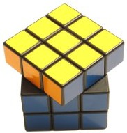 | 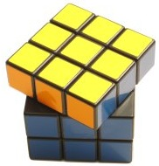 | 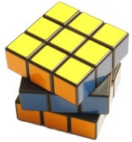
Solved = no penalty  Misalignment <= 45° | Solved, with penalty  Only 2 adjacent parts misaligned > 45° | Not solved  2 misalignments > 45°
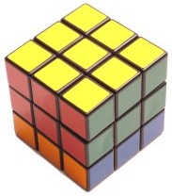 | 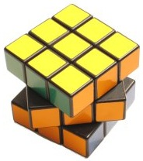 | 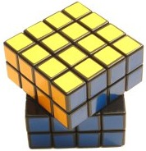
Solved, with penalty  1 misalignment > 45° | Solved = no penalty  All misalignments <= 45° | Solved = no penalty  Misalignment <= 45°
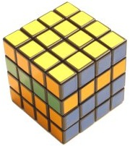 | 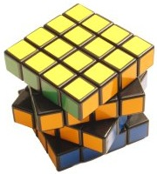 | 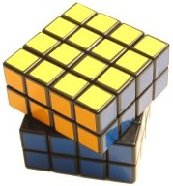
Not solved  2 misalignments > 45° | Solved = no penalty  All misalignments <= 45° | Solved, with penalty  1 misalignment > 45°

- Other puzzles are solved according to the solved state as defined in the generally accepted goal of the puzzle, with the regulations of the cube solved state applied when applicable.

For any Doubts, contact: Sushant Mehrotra 7607453700
Mayank Agarwal 9161379029

